SolarBillIQ Executive Summary
SolarBillIQ is an AI-powered electricity plan comparison platform designed for solar homeowners in the Oncor service territory, with an initial focus on Frisco, Texas. The application helps users identify the lowest total annual electricity cost by analyzing solar production, energy consumption, exported energy, utility delivery charges, and electricity plan structures.
Business Objective
The platform enables homeowners to compare solar buyback plans, free nights plans, battery strategies, and EV-focused plans using actual usage and solar production data. The primary goal is to determine the most cost-effective electricity strategy while ensuring that Oncor TDU delivery charges are treated accurately and not incorrectly offset by solar buyback credits.
User Workflow Overview
Users create an account, enter monthly energy usage and solar production information, and optionally upload:
- Solar production CSV files
- Smart Meter Texas usage data
- Electricity bill PDFs
The system validates uploaded data, performs plan comparisons, ranks available plans by annual cost, and provides a recommendation with supporting explanations. Historical comparisons and uploaded files are retained for future review.
Key Capabilities
Intelligent Plan Comparison
The application evaluates multiple electricity plans and strategies including:
- Solar buyback plans
- Battery-enhanced strategies
- EV-optimized plans
- Free Nights plans
- Virtual Power Plant (VPP) opportunities
Results are ranked based on estimated annual cost, with recommendations tailored to customer circumstances.
Data-Driven Analysis
Users can leverage actual:
- Solar production data
- Smart Meter Texas consumption data
- Current electricity bill information
Uploaded data supersedes manually entered values, increasing accuracy and reducing assumptions.
Transparent Cost Modeling
A core design principle is maintaining transparency around electricity pricing. The platform explicitly separates:
- Energy charges
- Solar buyback credits
- TDU delivery charges
- Base fees
The comparison engine ensures TDU charges remain visible and are not incorrectly reduced by solar export credits unless a plan explicitly supports such treatment.
Architecture Summary
SolarBillIQ is built using a modern AI-driven architecture consisting of:
- React frontend
- FastAPI backend
- LangGraph workflow orchestration
- LangChain tool framework
- MCP integrations
- SQLite operational database
- Pinecone vector database
- LlamaIndex document ingestion and retrieval
The architecture supports structured calculations, document retrieval, plan analysis, AI-generated explanations, and future multi-domain expansion.
Data Management
The platform stores:
- User accounts
- Plan comparison results
- Audit logs
- Uploaded file metadata
- Electricity plan catalogs
- TDU charge information
All operational data is persisted in SQLite, while uploaded files are stored using content-hash naming for traceability and deduplication.
AI & Extensibility
The system supports:
- AI-generated recommendation narratives through Anthropic Claude
- MCP-based tool integrations
- Multi-agent routing architecture
While the energy domain is production-ready, the architecture is designed to expand into finance and healthcare domains through external MCP servers and domain-specific AI workflows.
Strategic Benefits
- Reduces homeowner electricity costs through objective plan comparison.
- Provides trustworthy analysis by correctly handling solar buyback and TDU charge calculations.
- Supports real-world utility, solar, and billing data ingestion.
- Creates a scalable AI platform capable of expanding beyond energy use cases.
- Establishes a foundation for advanced AI-assisted decision support using LangGraph, RAG, MCP, and vector search technologies.
Executive Takeaway
SolarBillIQ delivers a practical AI-powered decision-support platform that helps Texas solar homeowners identify the lowest-cost electricity strategy while maintaining regulatory and billing accuracy. The solution combines deterministic cost calculations with modern AI technologies to provide transparent, auditable, and scalable energy-plan recommendations.
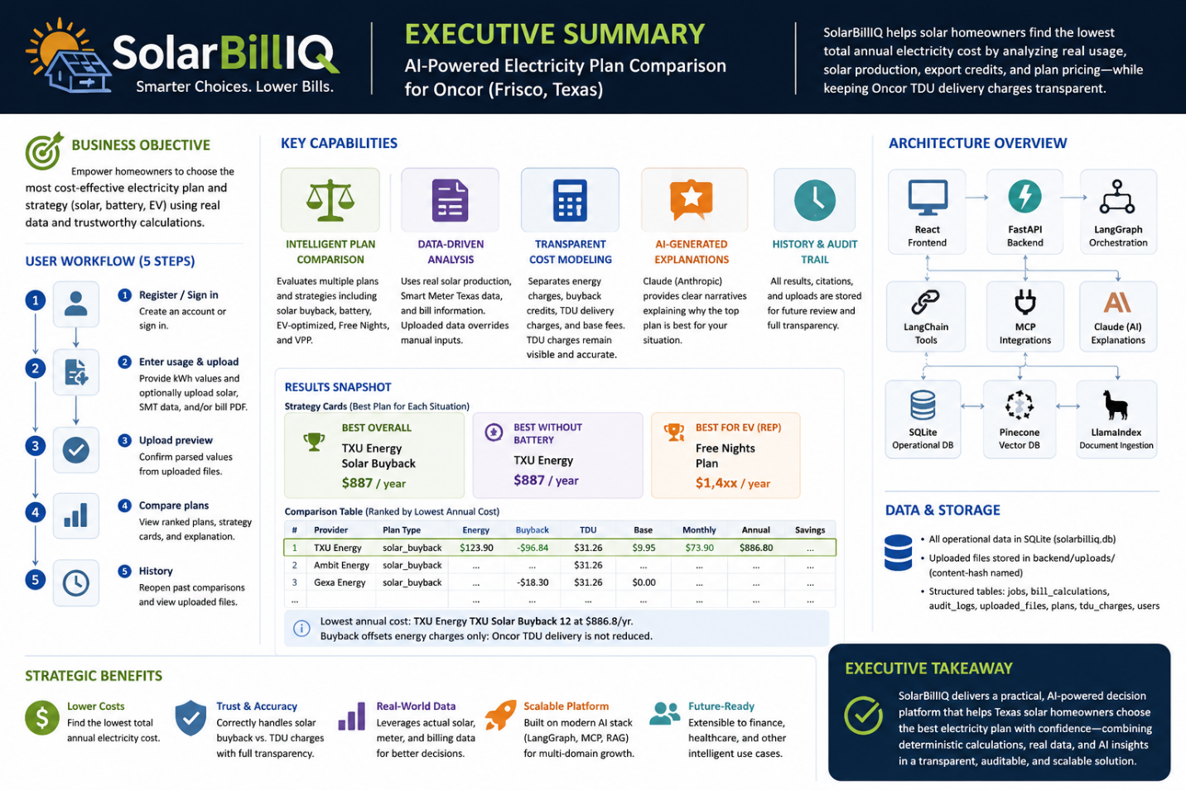

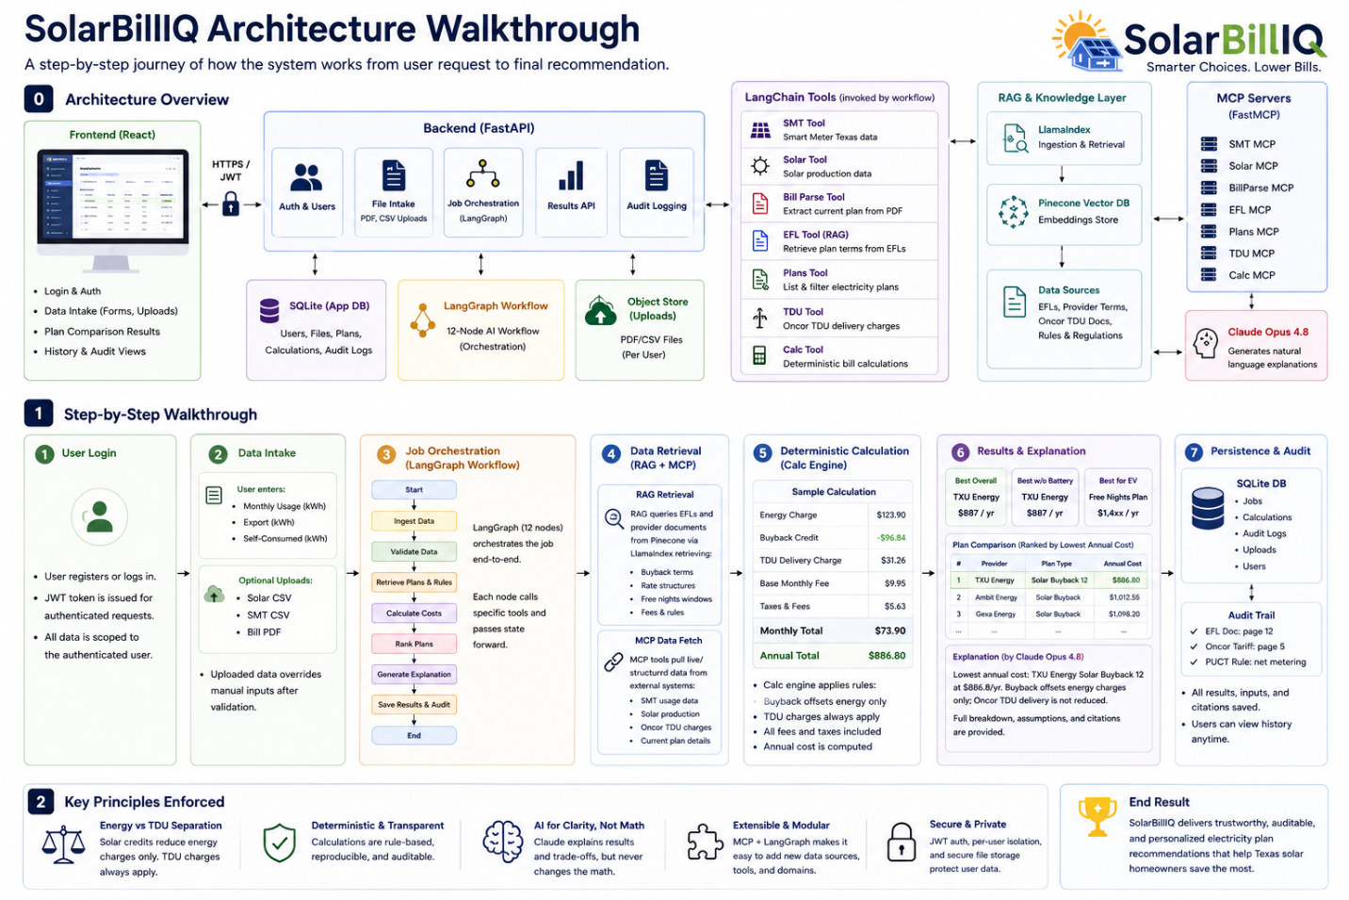
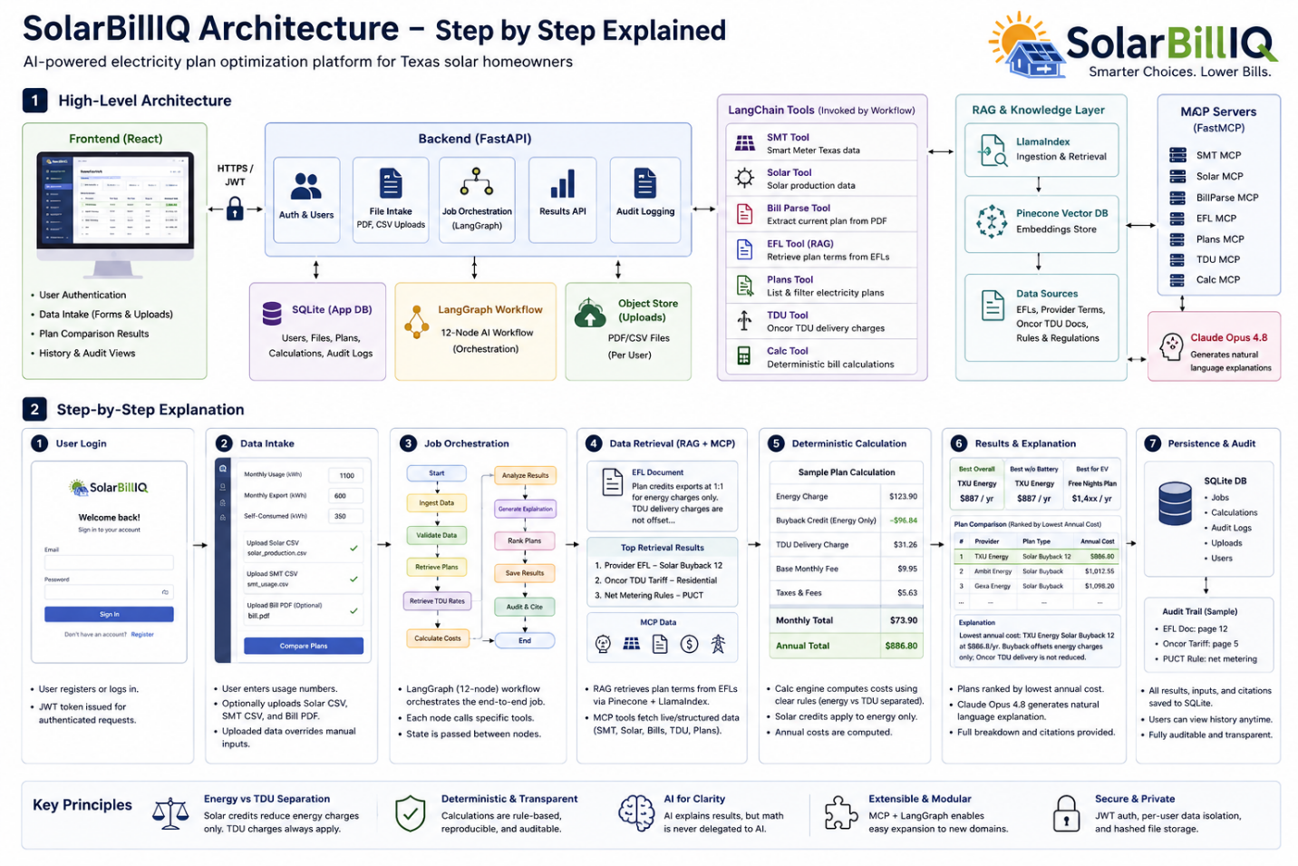

User Interface:
